**ASSIGNMENT-4**

**DISTANCE DETECTION USING ULTRASONICSENSOR**

|  |  |
| --- | --- |
| Date | 01 November 2022 |
| Name | Thoshima B |
| Student Roll  Number | 962219205047 |
| Maximum Marks | 2 Marks |

**Question:**

Write code and connections in wokwi for ultrasonic sensor. Whenever distance is less than 100 centimetersit should send "alert" to IBM cloud and display in device recent events

# Code:

#include <WiFi.h> #include <PubSubClient.h> #include <ArduinoJson.h>

WiFiClient wifiClient; #define ORG "9tg03j"

#define DEVICE_TYPE "RaspberryPi"

#define DEVICE_ID "12345"

#define TOKEN "12345678"

#define speed 0.034

char server[] = ORG ".messaging.internetofthings.ibmcloud.com"; char publishTopic[] = "iot-2/evt/status1/fmt/json";

char topic[] = "iot-2/cmd/home/fmt/String"; char authMethod[] = "use-token-auth";

char token[] = TOKEN;

char clientId[] = "d:" ORG ":" DEVICE_TYPE ":" DEVICE_ID;

PubSubClient client(server, 1883, wifiClient); void publishData();

const int trigpin=5;

const int echopin=19; String command; String data=""; String name="Alert"; String icon="";

long duration; int dist;

void setup()

{

Serial.begin(115200); pinMode(trigpin, OUTPUT); pinMode(echopin, INPUT); wifiConnect(); mqttConnect();

}

void loop() { publishData(); delay(500);

if (!client.loop()) { mqttConnect();

}

}

void wifiConnect() {

Serial.print("Connecting to "); Serial.print("Wifi"); WiFi.begin("Wokwi-GUEST", "", 6);

while (WiFi.status() != WL_CONNECTED) { delay(500);

Serial.print(".");

}

Serial.print("WiFi connected, IP address: "); Serial.println(WiFi.localIP());

}

void mqttConnect() {

if (!client.connected()) {

Serial.print("Reconnecting MQTT client to "); Serial.println(server); while (!client.connect(clientId, authMethod, token)) { Serial.print(".");

Serial.print("*"); delay(1000);

}

initManagedDevice(); Serial.println();

}

}

void initManagedDevice() {

if (client.subscribe(topic)) { Serial.println(client.subscribe(topic)); Serial.println("subscribe to cmd OK");

}

else {

Serial.println("subscribe to cmd FAILED");

}

}

void publishData()

{

digitalWrite(trigpin,LOW); digitalWrite(trigpin,HIGH); delayMicroseconds(10); digitalWrite(trigpin,LOW); duration=pulseIn(echopin,HIGH); dist=duration*speed/2; if(dist<100){

dist=100-dist; icon="Not-Crashed";

}

else{ dist=0;

icon="Crashed";

}

DynamicJsonDocument doc(1024); String payload; doc["Name"]=name; doc["Impact"]=icon; doc["Distance"]=dist; serializeJson(doc, payload); delay(3000);

Serial.print("\n"); Serial.print("Sending payload: "); Serial.println(payload);

if (client.publish(publishTopic, (char*) payload.c_str())) { Serial.println("Publish OK");

}

else {

Serial.println("Publish FAILED");

}

}

# DIAGRAM:

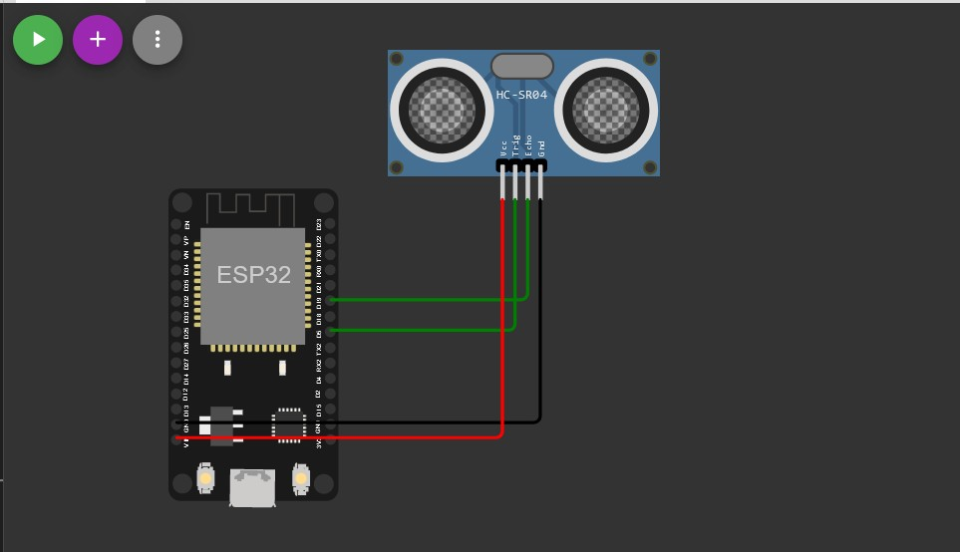

**OUTPUT:**

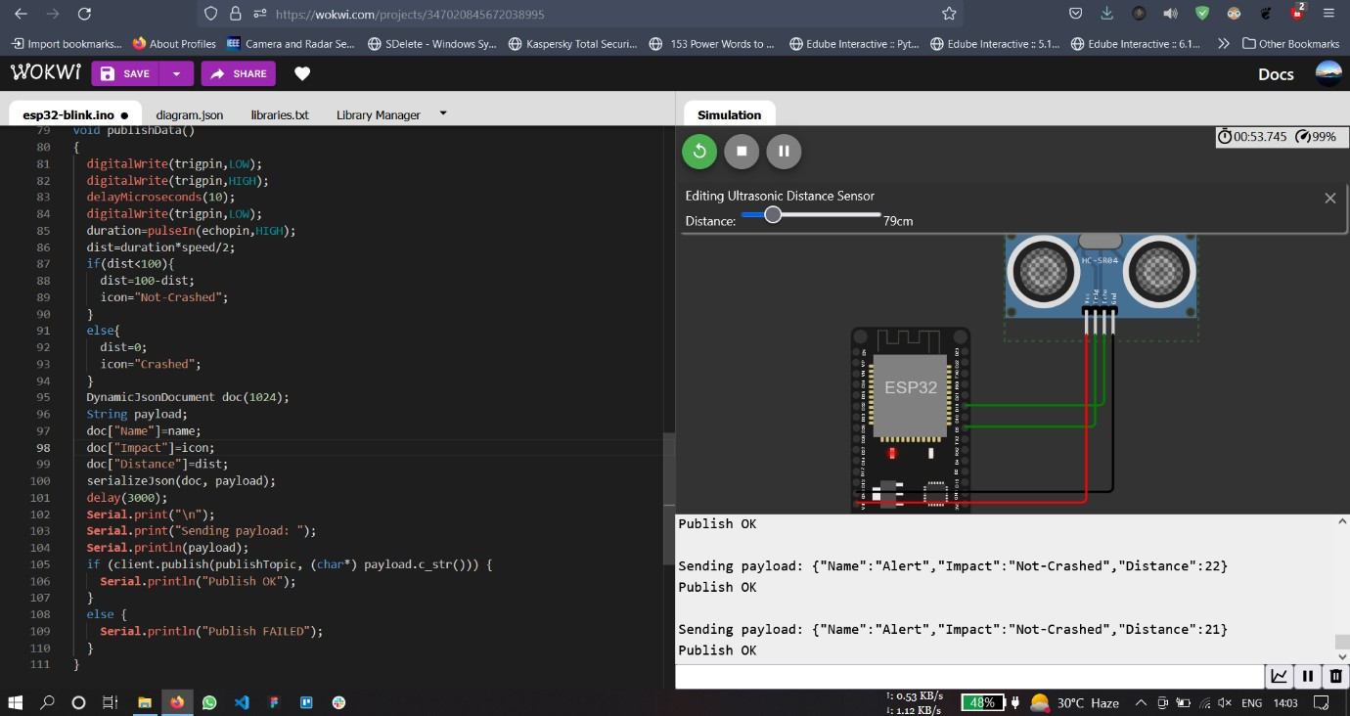

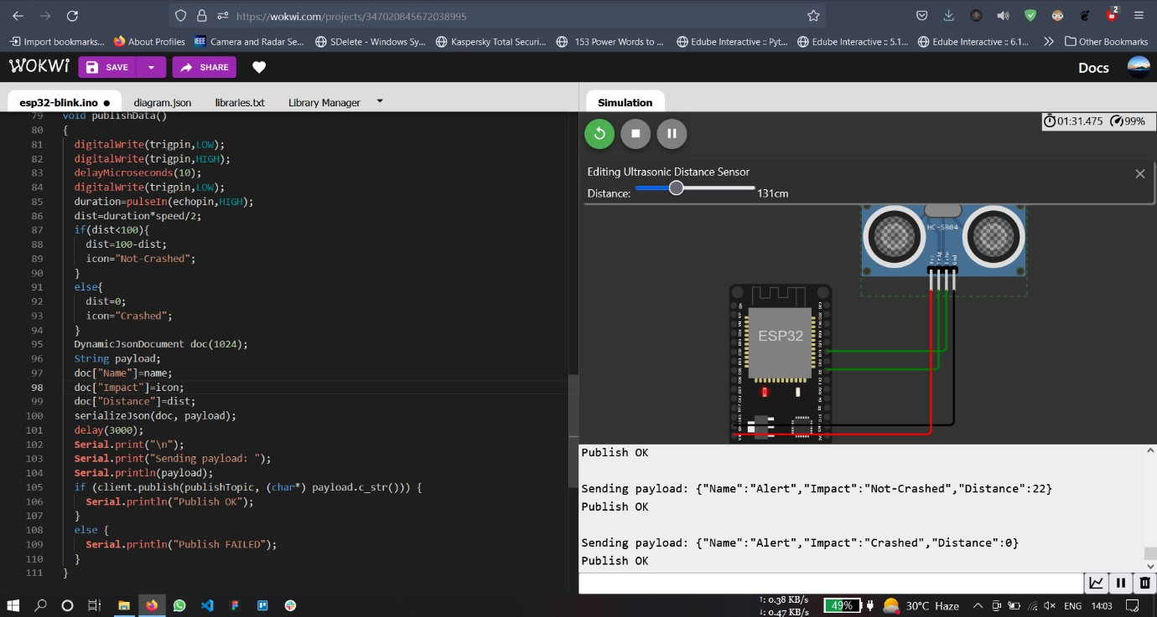

## Data uploaded to Iot Watson Platform

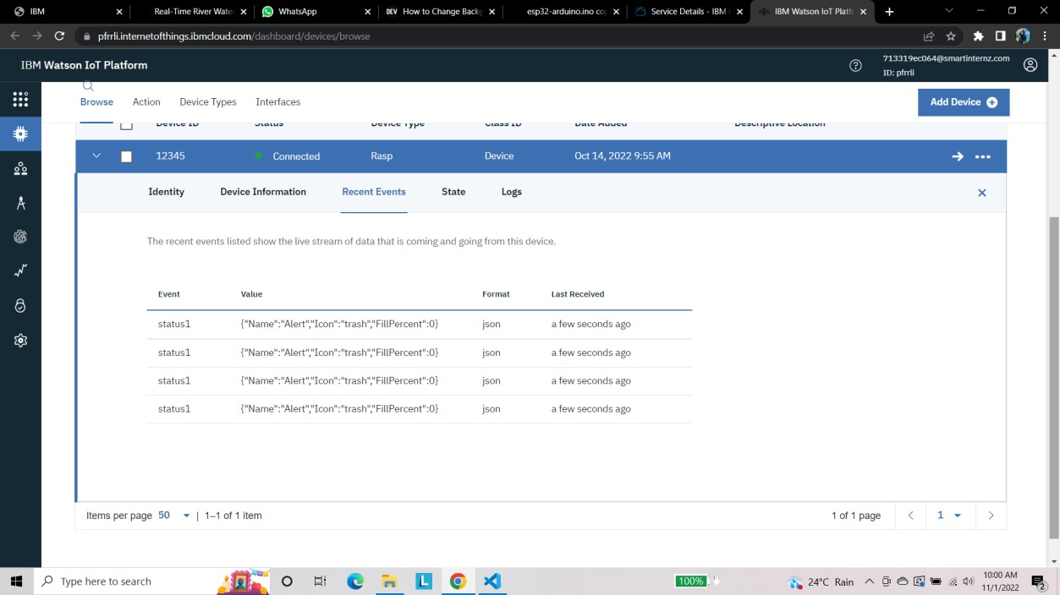

<https://wokwi.com/projects/347027183915500115>